13/01/19

**THM 121 Business Mathematics**

**Final Exam Answer Sheet**

**Note to the students**:

* Calculations to reach your answers shall be thoroughly shown. Otherwise, questions will NOT be graded.
* You can use a calculator throughout the exam.

1. Write the equation of the line with the given properties: (**3** Points)

Passes through the point (3, 5) and is perpendicular to the line χ + y = 4.

The given line χ + y = 4 or y = - χ + 4, has a slope of -1. A perpendicular line shall have a slope of *m* = -1 / (-1) = 1. Given that the point (3, 5) is on the line, the equation of the line shall be:

*y* – 5 = 1 (χ – 3) or ***y* = χ + 2**.

1. A credit card company estimates that the average cardholder owed $ 7,853 in the year 2013 and $ 9,127 in 2018. Suppose average cardholder debt *D* grows at a constant rate.
2. Express *D* as a linear function of time *t*, where *t* is the number of years after 2013. Draw the graph of this function. (**4** Points)

Since *t* = 0 mean year 2013, *t* = 5 corresponds to year 2018. The given information translates to the points (0, 7853) and (5, 9127). The slope of the line that passes through these points is:

*m* = (9127 – 7853) / (5 – 0) = 254.80. Therefore, the equation of the function is:

***D*(*t*) = 254.80 *t* + 7853**

For practical purposes, the graph is limited to quadrant I.

1. Use the function in part a) to predict the average cardholder debt in the year 2023. (**1** Point)

Year 2023 corresponds with *t* = 10 so the predicted average cardholder’s debt in 2023 is:

*D*(*t*) = 254.80 * 10 + 7853 = 10,401.

Therefore, the average cardholder’s debit in 2023 is predicted to be **$ 10,401**.

1. Approximately when will the average cardholder debt be double the amount in the year 2013? (**2** Points)

To answer this question, we shall equate ***D*(*t*)** = 2 * 7853 and solve for t:

254.80 *t* + 7853 = 15706 ↔ 254.80 *t* = 7853 ↔ *t* ≈ 30.82. Therefore, the average cardholder’s debt will double the 2013 amount approximately **during the year of 2043**.

3) A manufacturer estimates that each unit of a particular commodity can be sold for $ 3 more than it costs to produce. There is also a fixed cost of $ 17,000 associated with the production of the commodity.

a) Express total profit *P*(χ) as a function of the level of production χ. (**2** Points)

Let *p* be the selling price of the commodity and χ be number of units produced / sold. Then (Assuming Number of Units Produced = Number of Units Sold):

Profit = Revenue – Cost ↔ (Number of units Sold * Selling Price) – ((Number of Units Produced * Cost per Unit) + Fixed Overhead Cost) ↔ *P*(χ) = p χ – ((p – 3) χ + 17000) ↔ ***P*(χ) = 3 χ – 17000**.

b) How much profit (or loss) is generated when χ = 5,000 units are produced? When χ = 20,000? What is the smallest number of units that must be sold for production to be profitable? (**2** points)

*P* (5000) = 3 * 5000 – 17000 = **- $ 2,000** (Loss).

*P* (20000) = 3 * 20000 – 17000 = **$ 43,000** (Profit).

The minimum number of units to be sold for the production to be profitable is obtained by equating *P* (χ) = 0 ↔ 3 χ – 17000 = 0 ↔ 3 χ = 17000 ↔ χ ≈ 5666.67. Therefore, when **5,667** units are produced and sold, production becomes profitable.

1. Find the average profit function *AP*(χ). What is the average profit when 10,000 units are produced? (**2** Points)

*AP* (χ) = *P* (χ) / χ = 3 – 17000 / χ

When 10,000 units are produced, the average profit is 3 – 17000 / 10000 = 1.30.

Therefore, the average profit is **$ 1.30** per unit when 10,000 units are produced.

1. Producers will supply χ units of a certain commodity to the market when the price is *P* = *S*(χ) dollars per unit, and consumers will demand (i.e. buy) χ units when the price is *P* = *D*(χ) dollars per unit, where:

***S*(χ) = 2 χ + 15 and *D*(χ) = 385 / (χ + 1)**

1. Find the equilibrium production level **χe** and the equilibrium price **Pe**. (**2** Points)

Equilibrium occurs when *S*(χ) = *D*(χ) ↔ 2 χ + 15 = 385 / (χ + 1) ↔ (2χ + 15) (χ + 1) = 385 ↔ 2χ2

+ 17χ + 15 = 385 ↔ 2χ2 + 17χ – 370 = 0. Using the quadratic formula,

So χ = 10 (disregard the negative root). Therefore, the corresponding equilibrium price is *p* = *S*(χ) =

*D*(χ), or *p* = 2 (10) + 15 = 35.

Hence χe = **10 units** and and Pe = **$ 35**.

1. Draw the supply and demand curves on the same graph. (**3** Points)

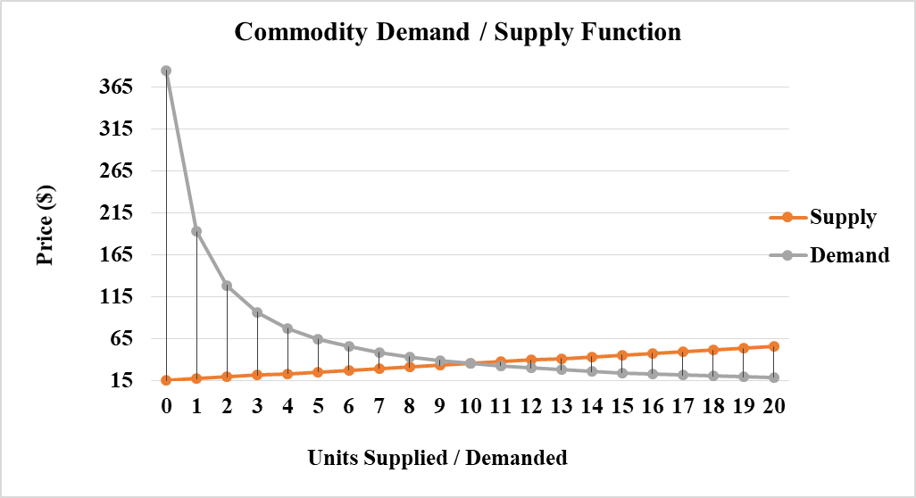

1. Where does the supply curve cross the y axis? Describe the economic significance of this point? (**2** Points)

The supply curve intersects the y-axis at *S*(0) = 15. Since this is the price at which producers are willing to supply zero units of the commodity. This corresponds to their overhead (Fixed Cost) at the start of production.

1. Find the indicated limit of the following function (if it exists): (**3** Points)



$$\begin{aligned}\begin{aligned}lim \\ x→5\end{aligned}{}{(x}^{2}-3x-10)/(x-5)\end{aligned}{ }$$

1. The concentration of a drug in a patient’s bloodstream *t* hours after an injection is C(*t*) milligrams per milliliter where:

**C(*t*) = (0.40 / (t2 + 1)) + 0.013**

1. What is the concentration of drug immediately after the injection (i.e. when t = 0)? (**1** Point)

*C*(0) = (0.40 / (02 + 1)) + 0.013 = **0.41 mg / ml**.

1. By how much does the concentration change during the 5th hour? Does it increase or decrease over this time period? (**2** Points)

*C*(5) – *C*(4) = [(0.40 / (52 + 1)) + 0.013] – [(0.40 / (42 + 1)) + 0.013] = (0.40 / 26) – (0.40 / 17) = **- 0.01 mg / ml**.

Therefore, during the 5th hour, the concentration **decreases** by **0.01 mg / ml**.

1. What is the residual concentration of drug, that is, the concentration that remains in the long run (as *t* → ∞)? (**2** Points)

The answer to this is the limit of C(*t*) as t approaches ∞. Therefore, the residual concentration of drug that remains in the long run is **0.01 mg/ml**.

1. List all the values of χ for which the given function is not continuous. (**2** Points)

$$f(x)=\left\{\begin{aligned}2x+3 if &x≤1 \\ 6x-1 if &x>1\end{aligned}\right.$$

*f* is defined for all real numbers. Further, 

so there are no values for which *f* is not continuous.

1. In certain situations, it is necessary to weigh the benefit of pursuing a certain goal against the cost of achieving that goal. For instance, suppose that to remove χ% of the pollution from an oil spill, it costs *C* thousands of dollars, where:

***C*(χ) = 12χ / (100 – χ)**

1. How much does it cost to remove 25 % of the pollution? 50%? (**2** Points)

C(25) = (12 * 25) / (100 – 25) = 4. It would cost **$ 4,000** to remove 25 % of the population.

C(50) = (12 * 50) / (100 – 50) = 12. It would cost **$ 12,000** to remove 50 % of the population.

1. Sketch the graph of the cost function C. (**3** Points)

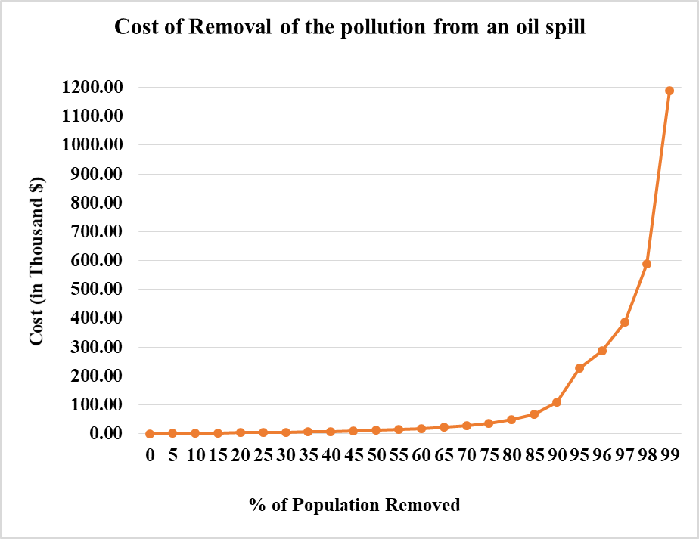

1. What happens as **χ → 100-**? Is it possible to remove all the pollution? Why? Why not? (**2** Points)

From the graph, since

  
we can conclude that it is impossible to remove all of the population.

**N.B**. Round your answers to the **nearest cent** for questions 2, 3, 4, 6 & 8.

**GOOD LUCK!**